Statistics Assignment #2
1. Problem 08 page 200
The Sheriff’s office sampled in LEMAS (N = 827) reported that their agencies require new recruits to complete a mean of 599 hours of academy training (s = 226). Construct a 99 % confidence interval around this mean and interpret the interval in words.
sample size N = 827
sample mean = 599
sample standard dev s = 226
Confidence level = 99%
level of significance alpha = 100 - confidence level = 1%
A 99% level of confidence generates a 1% chance of an inaccurate CI.
It is two tailed so 1% divided in half is .5% and converted to a proportion is .005.
.50 - .005 = .4950.
This exact value does not appear in the z table, so the z scores associated with the two closest values (.4949 and .4951) must be averaged.
These scores are 2.57 and 2.58
(257 + 258) /2
= 2.575
CI = x̅ +- z_{α} ($\frac{s}{\sqrt{N-1}}$)
z_{α} at 99% is 2.575
= 599 +- 2.575 ($\frac{226}{\sqrt{827-1}}$)
= 599 +- 20.249
Lower limit is (599 – 20.249)
and upper limit is (599 + 20.249)
99% CI = (578. 751, 619.249)
Therefore, there is a 99% chance that the true population mean is 619.249, 578.751, or some number in between.
2. Problem page 200
In the PPCS, respondents who say that they have been stopped by police while driving vehicles are asked to report the reason why they were stopped and the total length of time that the stop took. Among female drivers stopped for illegal use of cellphones while driving (N = 42), stops lasted a mean of 9.00 minutes (s = 5.48). Construct a 95% confidence interval around this sample mean and interpret the interval in words.
N = 42, Mean = 9.00, s = 5.48
Confidence level = 95%
level of significance alpha = 100 - confidence level = 5% which is .05
df = 42- 1 = 41
The df = 41 is not located on the table, so we must use the df = 40 row instead.
The critical value of t is ±2.021.
CI = x̅ +- t_{α} ($\frac{s}{\sqrt{N-1}}$)
CI = 9.00 +- 2.021 ($\frac{5.48}{\sqrt{42-1}}$)
= 9.00 +- 1.730
Upper limit is 9.00 + 1.730
= 10.730
Lower limit is 9.00 – 1.730
= 7.270
Therefore, there is a 95% chance that the true population mean is 10.730, 7.270, or some number in between.
3. Problem 16 page 200
In the LEMAS survey, 45% of sampled sheriff’s offices (N = 823) reported that their agencies’ formal mission statements do not include a community-policing component. Construct a 95% confidence interval around this sample value, and interpret the interval in words.
N = 823
P = 0.45
1 - P = 0.55
Confidence level = 95%
level of significance alpha = 100 - confidence level = 5% which is .05
z_{α} at 95 confidence level is +- 1.96
CI = P +- z_{α} $\sqrt{\frac{p (1-p)}{N}}$
CI = 0.45 +- 1.96 $\sqrt{\frac{0.45 (1-0.45)}{823}}$
CI = 0.45 +- 0.034
Upper limit is 0.45 + 0.034
= 0.484
Lower limit is 0.45 – 0.034
= 0.416
Therefore, there is a 95% chance that the true population mean is found in the interval 0.484, 0.416, or some number in between.
4. Problem 20 page 201
The GSS found that 74% of male respondents (N = 573) believe that people suffering from incurable diseases should be permitted to die if that is their choice. Construct a 99% confidence interval around this sample value, and interpret the interval in words.
N = 573
P = 0.74
1 - P = 0.36
Confidence level = 99%
level of significance alpha = 100 - confidence level = 1% which is .01
z_{α} at 99 confidence level is +- 2.575
CI = P +- z_{α} $\sqrt{\frac{p (1-p)}{N}}$
CI = 0.74 +- 2.575 $\sqrt{\frac{0.74(1-0.26)}{573}}$
CI = 0.74 +- 0.047
Upper limit is 0.74 + 0.047
= 0.787
Lower limit is 0.74 – 0.047
= 0.693
Therefore, there is a 99% chance that the true population mean is found in the interval 0.787, 0.693, or some number in between.
5. Problem 04 page 274
A research wants to test the hypothesis that police are likely to arrest a suspect if the suspect has a full-time job. The research gathers a sample and measures job status as employed or unemployed and records the proportion of each group that arrested.
What is the independent variable?
Job Status measured as (employed or unemployed)
What is the level of measurement of the independent variable?
Categorical level of measurement (Nominal variable).
What is the dependent variable?
Suspects arrested
What is the level of measurement of the dependent variable?
Continuous level of measurement (ratio variable).
6. Problem 14 Page 275
Are juvenile defenders who are released pending adjudication processed more slowly than those who are detained? The JDCC data set records whether a juvenile was released and the number of months it took for that juvenile’s case to reach a disposition. The sample will be narrowed to black female youth. Released juveniles (sample 1) had a mean of 4.30 months to disposition (s= 3.86, N = 123) and detained juveniles (sample 2) had a mean of 3.57 (s = 4.20, N = 64). Using an alpha level of .01, test the hypothesis that released juveniles’ mean time-to-adjudication is significantly greater than detained juveniles’ mean. Assume equal population variances. Use all five steps.
Step 1:
H0: µ1 = µ2
H1: µ1 > µ2
Step 2:
The distribution is t and the df formula is
df = N1 + N2 – 2 because the samples have equal variances
N1 = 123 and N2 = 64
123 + 64 -2
df = 185
Step 3: the critical value and state the decision rule.
At 185 df and .05 level of significance, the t value is 1.6531 since there is directionality in the alternative hypothesis.
Step 4: the obtained value of the test statistic.
Formula for Standard error is:
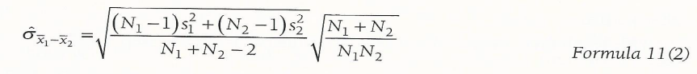
= $\sqrt{\frac{\left(123-1\right){3.86}^{2}+\left(64-1\right){4.20}^{2}}{123+64-2}}$ $\sqrt{\frac{123+64}{123 x 64}}$
= 0.6133
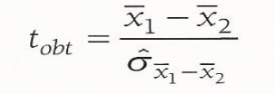
= $\frac{4.30-3.57}{0.6133}$
= 1.190
Step 5:
Since the calculated t value (1.190) is less than the tabulated t value (1.6531), we fail to reject the null hypothesis.
The conclusion is that juvenile defenders who are released pending adjudication are not processed more slowly than those who are detained.
7. Problem 18 page 276
In question 16, you tested for a relationship between black and Hispanic juveniles in terms of the length of probation sentences received. Now let’s find out whether there is a between-group differences among those sentenced to community service. The following table shows pairs of youths matched on gender (male) and offense type (weapons) using an alpha level of .05, test the hypothesis that there is a statistically significant difference between the groups’ mean, use all the five steps.
Pair | Community service sentence  (hours)
Pair | Black | Hispanic | x_{D} = x₁ – x₂ | x_{D} - x̅_{D} | (x_{D} - x̅_{D})²
Pair A | 25 | 30 | 25 – 30  = -5 | -5 – 0.6  = -5.6 | 31.36
Pair B | 50 | 40 | 10 | 9.4 | 88.36
Pair C | 48 | 50 | -2 | -2.6 | 6.76
Pair D | 100 | 110 | -10 | -10.6 | 112.36
Pair E | 40 | 30 | 10 | 9.4 | 88.36
 |  |  | x̅_{D} = $\frac{3}{5}$  = 0.6 |  | $$\sum{{\left(xD - \overline{x}D\right)}^{2}}$$  = 327.2

Step 1: Hypothesis
H0: µ1 = µ2
H₁: µ₁ ≠ µ₂
Step 2: identifying the distribution and computing the degrees of freedom
The distribution is t
The df for pairs is: df = Npairs - 1
= 5 -1 = 4
Step 3: critical value
With an alpha of .05, a two-tailed test, and df = 4, the absolute value derived using the t table is +/- 2.776298.
Step 4: Compute the obtained value of the test statistic
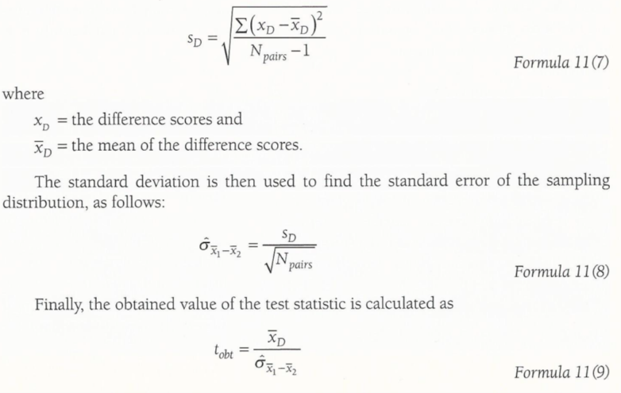
$\sum{{\left(x_{D}- {\overline{x}}_{D}\right)}^{2}}$ = 327.2 as calculated in the table
SD = $\sqrt{\frac{327.2}{5-1}}$
= 9.0443
Standard error = $\frac{SD}{\sqrt{N}}$
= $\frac{9.0443}{\sqrt{5}}$
= 4.0447
Obtained value of t = $\frac{x_{D}}{Standard error}$
= $\frac{0.6}{4.0447}$
= 0.1483
Step 5: making a decision
The decision rule stated that the null would be rejected if the obtained value was less than -2.776298 or greater than 2.776298.
With t_{obt}, = 0.1483, the null hypothesis is retained
The conclusion is that there is no difference among those sentenced to community service.

